Time Series Analysis of Expenditure Data for State House and Senate

Submitted by:
Akash Bhupesh Singh
Date:
12/10/2024
Contact Information:
aksingh2@iastate.edu

Abstract
This study analyzes and forecasts expenditure data for the General Assembly of Iowa, specifically focusing on the State House and Senate committees. Using publicly available datasets from the Iowa government’s open data portal, we extracted and filtered data related to campaign contributions, expenditures, and registered political committees. The analysis focuses on the financial activities during the elections, highlighting their critical role in shaping political outcomes and governance. Given Iowa’s political landscape, which is largely influenced by the Republican Party, this study examines trends in expenditures for State House and Senate committees to gain insights into spending behavior and predict future expenditures using time series techniques. Key findings include the identification of expenditure trends, committee-specific analysis, and time series forecasts utilizing ARIMA models. This research emphasizes the importance of financial transparency in elections and offers valuable insights for policymakers, political analysts, and stakeholders involved in Iowa’s General Assembly elections.

Introduction

Elections play a pivotal role in shaping governance and policy-making in democratic systems. Financial activities, including campaign expenditures, form a significant component of electoral processes, as they provide insights into resource allocation, political priorities, and the scale of competition among candidates and committees. This study focuses on the General Assembly elections in Iowa, specifically analyzing expenditures for the State House and Senate committees. Iowa’s political environment is heavily influenced by the Republican Party, making the examination of campaign expenditures an essential part of understanding electoral dynamics in the state.

The datasets used in this study are sourced from the official Iowa government open data portal. The three primary datasets include information on:

1. Registered Political Committees (committees and their attributes).

2. Campaign Contributions (details of contributions received).

3. Campaign Expenditures (financial expenditures made by committees).

The analysis specifically filters these datasets to focus on the General Assembly elections, categorized by committee types for the State House and State Senate. By analyzing and forecasting expenditure trends, this study aims to identify key spending patterns and predict future expenditures using time series analysis methods. The findings contribute to a deeper understanding of how financial resources are utilized in Iowa’s General Assembly elections and highlight the importance of campaign financing in influencing electoral outcomes.

Problem Statement
The primary objective of this project is to analyze the trends in campaign expenditures for the State Senate and State House of the General Assembly of Iowa using publicly available datasets. Elections play a pivotal role in shaping policy and governance, and understanding campaign expenditures is critical for assessing financial transparency, spending patterns, and their impact on the electoral process.
This project focuses specifically on analyzing:
1. Expenditure Trends over time for committees involved in the Iowa General Assembly elections.
2. Identifying significant spending patterns, including top receiving organizations where funds are directed.
3. Highlighting challenges encountered during the analysis, such as negative values in expenditure forecasts and model overfitting.

Limitations of the Data
The analysis of campaign contributions and expenditures for the State Senate and State House of the General Assembly of Iowa has the following limitations:

The datasets do not include election outcomes such as winners, vote counts, or margins of victory, which restricts the ability to link campaign expenditures or contributions to success in elections. Additionally, some reports are filed on paper and may not be included in the datasets, leading to incomplete or missing data. Certain contributions or expenditures may also be misreported, impacting the accuracy of the analysis.

Another limitation is the lack of granularity in the data, as expenditure records do not provide detailed categorization or specify the exact purpose of spending. Geographic analysis is also limited since address information is only available for itemized transactions, making it difficult to perform comprehensive geospatial analysis.

The temporal coverage of the datasets starts from 2003, which prevents comparisons with earlier election cycles and limits the ability to analyze long-term trends. Moreover, the analysis focuses exclusively on State Senate and State House campaigns, leaving out other campaign categories and generalizing the findings.

Negative expenditure values appeared during time series forecasting, which required correction by replacing them with zero. Lastly, the limited number of data points led to overfitting in time series models, causing discrepancies between actual and forecasted expenditure values.

Data Description

Data Sources
- Iowa Campaign Expenditures
- Iowa Campaign Contributions Received
- Registered Political Candidates, Committees and Entities in Iowa

Datasets
This analysis relies on three key datasets (Before Appling the Committe Type Filter):
1. Iowa Campaign Expenditures
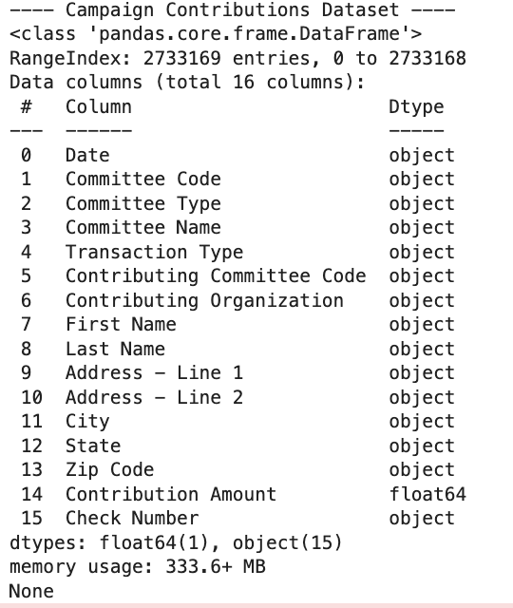
2. Iowa Campaign Expenditures
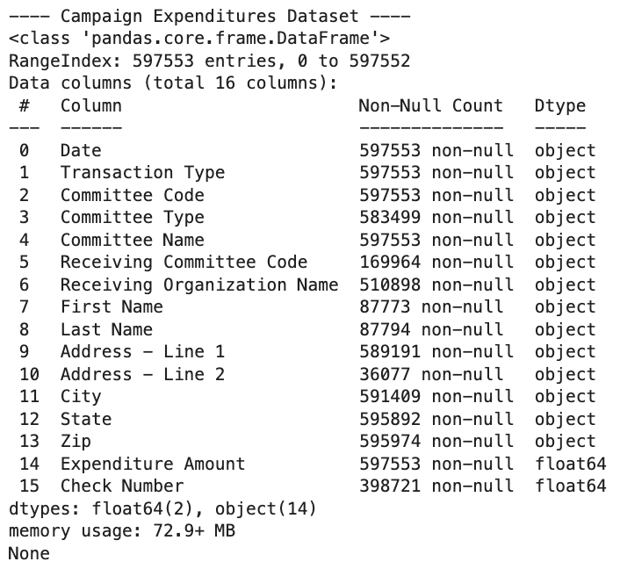
3. Registered Political Candidates, Committees and Entities in Iowa.
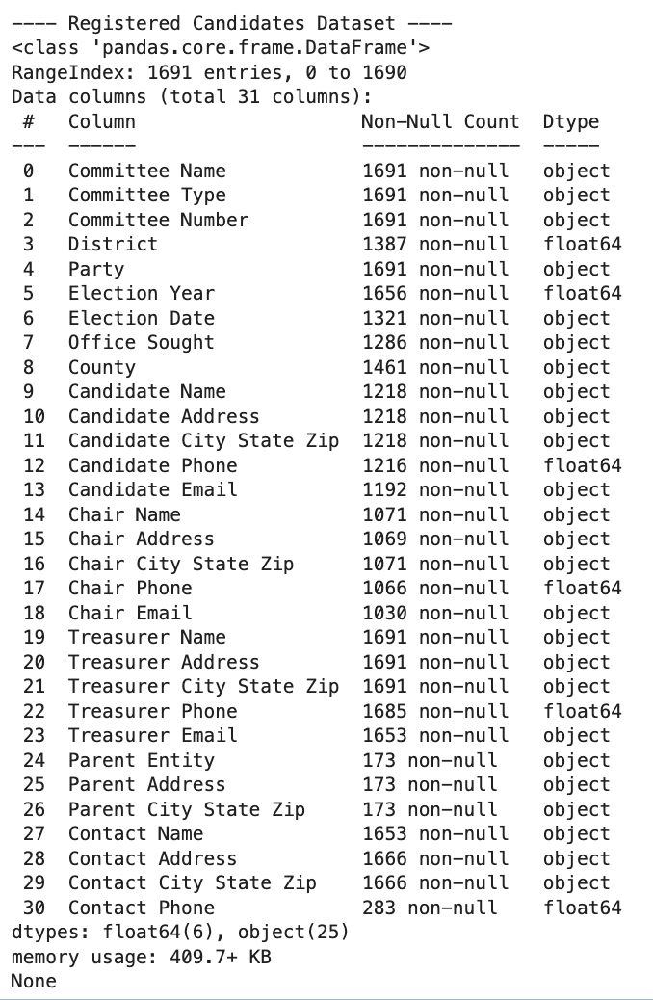

After applying the filtering criteria, the dataset was reduced in size, reflecting only the rows that met the specified conditions:
# Step 3: Filter the data based on 'Committee Type' (make sure the column name is correct)
filtered_data = data[data['Committee Type'].isin(['State House', 'State Senate'])]
- Iowa Campaign Expenditures
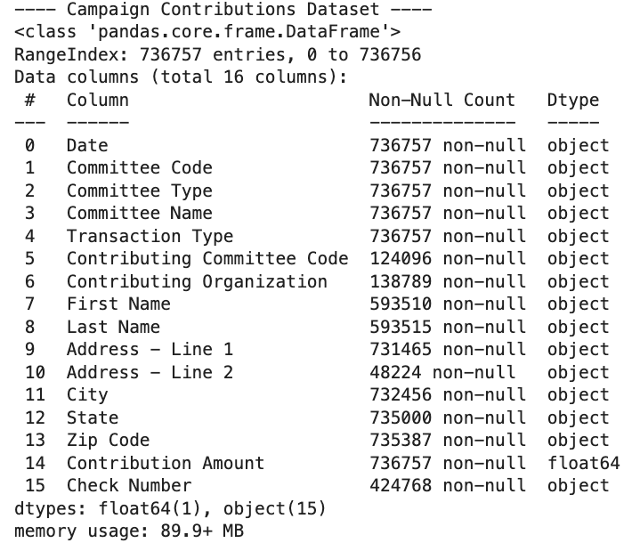
- Iowa Campaign Expenditures
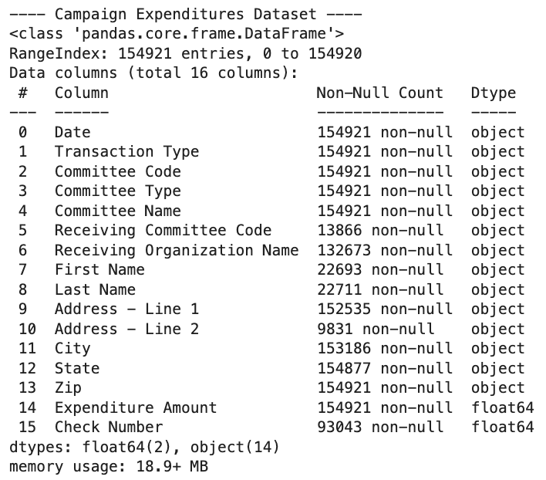
- Registered Political Candidates, Committees and Entities in Iowa
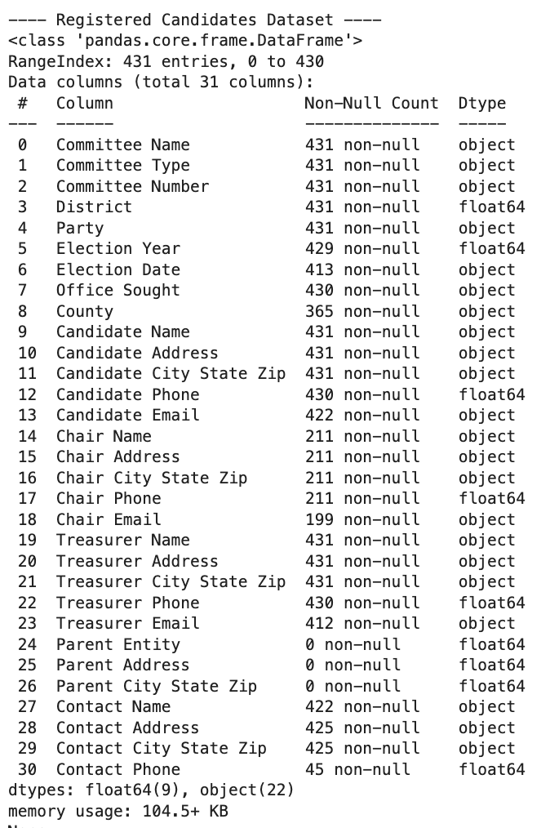

Key Variables
- Contribution Amount: Represents the total funds contributed to committees during the campaign period.
- Expenditure Amount: Details the spending activities of committees, reflecting where and how funds were allocated.
- Committee Type: Identifies the type of committee involved, such as State Senate and State House committees.
- Date: Records the timing of financial transactions, including contributions and expenditures, which allows for trend analysis over time.

Data Cleaning and Preprocessing
The data cleaning and preprocessing steps were crucial to prepare the datasets for meaningful analysis. This process involved filtering the relevant data, handling missing values, ensuring data consistency, and converting date formats for time series analysis. The three datasets – Contributions, Expenditures, and Candidates – underwent a structured cleaning workflow to ensure reliability and accuracy.

Step 1: Data Filtering
1 The raw data was first filtered to focus exclusively on the State House and State Senate committees. This ensured that only data relevant to the General Assembly elections of Iowa was considered.

Step 2: Data Cleaning Function
A standardized clean_dataset function was implemented to handle missing values, format columns, and remove duplicates. The function performed the following tasks:
- Handling Missing Values:
• Categorical columns were filled with 'Unknown'.
• Numerical columns were filled with the median value to avoid skewing data.
- Address Handling:
• Combined 'Address - Line 1' and 'Address - Line 2' into a single column called 'Full Address'.
• Missing values in addresses were replaced with 'Not Provided'.
- Date Conversion:
• Date columns were explicitly converted to datetime format using pd.to_datetime().
- Data Consistency:
• Standardized state abbreviations, ensuring only valid entries like 'IA' were retained.
• Zip codes were formatted as strings with leading zeros using .str.zfill(5).
- Duplicate Removal:
• Duplicate rows were removed to ensure data integrity.

Step 3: Applying Data Cleaning to Datasets

The cleaning function was applied to the Contributions, Expenditures, and Candidates datasets with specified columns for each.

Contributions Dataset:

• Missing values in 'Contributing Organization' and names were filled with 'Unknown'.

• Address columns were merged.

• Dates were converted to datetime format.

Expenditures Dataset:

• Missing values in 'Receiving Organization Name' and names were handled similarly.

• Address columns were merged.

• Numerical values like 'Expenditure Amount' were filled with the median.

Candidates Dataset:

• Missing values in names, party, and addresses were filled with 'Unknown'.

• Date fields like 'Election Date' were converted.

Step 4: Post-Cleaning Processing

A post_clean_process function was applied to ensure further cleaning and prepare the datasets for analysis:

Date Validation and Filtering:

• Ensured all date columns were in correct datetime format.

• Filtered data to include only records from January 1, 2003, to the current date.

Extracting Year:

• Extracted the year from the date columns to allow annual trend analysis.

Duplicate Validation:

• Revalidated that all duplicate rows were removed.

Step 5: Results After Cleaning
Contributions Dataset:
• Missing values were filled, and all records had valid dates within the specified range.
• Rows after cleaning: 736,756.

Expenditures Dataset:
• Address inconsistencies and missing organization names were handled.
• Rows after cleaning: 154,920

Candidates Dataset:
• Missing details in candidate names, emails, and addresses were filled appropriately.
• Rows after cleaning: 430.

Step 6: Summary of Cleaning Results
Before Cleaning:
• The datasets had significant missing values, particularly in organization names, addresses, and check numbers.
After Cleaning:
• All missing values were handled appropriately.
• Duplicate records were removed.
• Dates were filtered and validated for consistency.
• Address columns were combined for a cleaner presentation.

The cleaned datasets are now consistent, reliable, and ready for further analysis, including time series forecasting and trend exploration.

Exploratory Data Analysis (EDA)
The EDA provides insights into political contributions and expenditures for the Iowa General Assembly elections, specifically focusing on State House and State Senate committees. The analysis examines temporal trends, committee-level contributions, expenditures, and correlations between key metrics.

1. Contributions Analysis
1.1 Total Contributions Over the Years
• Description: A line plot visualizes the trend in total contributions across the years.
• Observations:
• Contributions follow a cyclical pattern, with peaks occurring in election years, particularly in 2010, 2016, and 2020.
• Contributions have shown a general upward trend, reflecting increased financial engagement in recent elections.
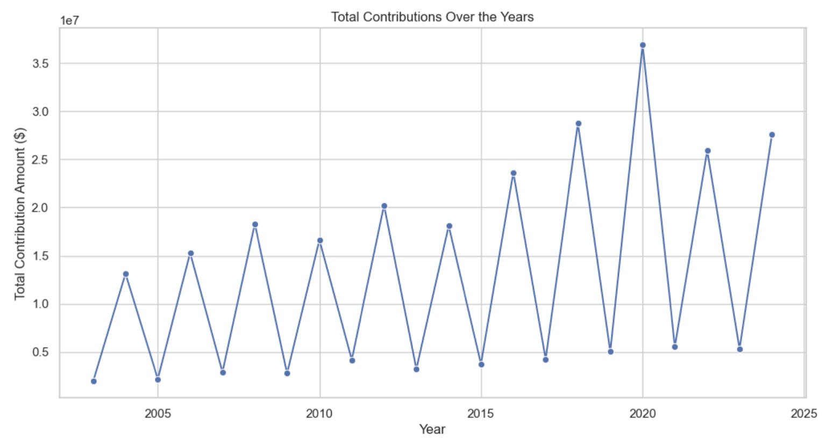

1.2 Contributions by Committee Type
• Description: Contributions were broken down by State House and State Senate committees.
• Observations:
• State House committees consistently received higher contributions compared to State Senate committees.
• Both committee types display a similar cyclical trend, with significant peaks during election years.
• Contributions for the State House peaked significantly in 2016 and 2020.
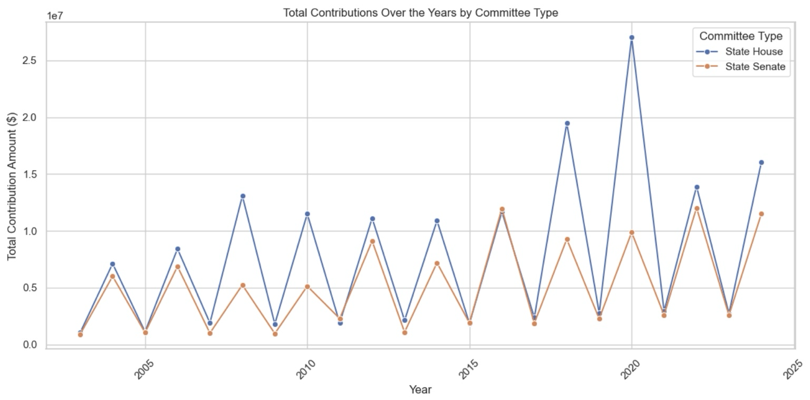

1.3 Top 10 Committees by Contributions
• Description: A bar chart identifies the top 10 committees with the highest contributions.
• Observations:
• Top Committees:
• Citizens for Gronstal (State Senate) received the highest contributions.
• Citizens for Pat Grassley (State House) and Friends of Whitver were also significant contributors.
•State Senate committees dominate the overall top committees in contributions.
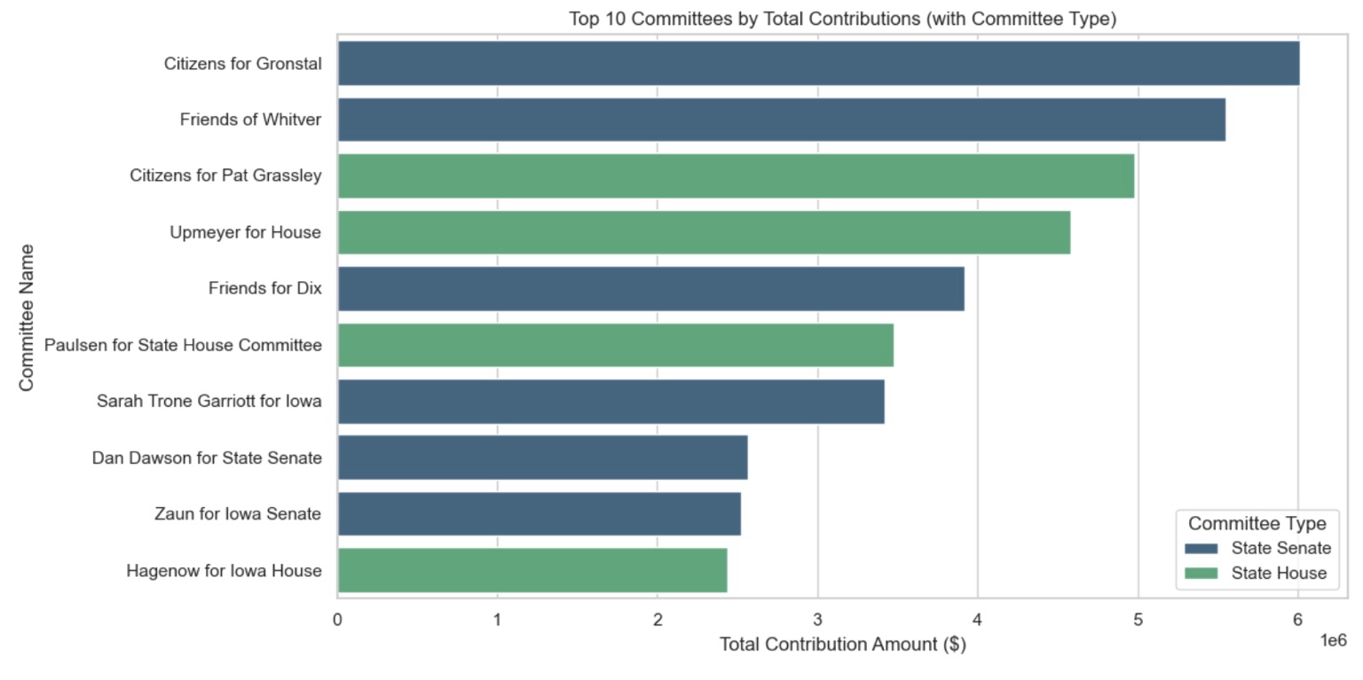

1.4 Top Contributions for State House and State Senate
• State House Committees:
- Citizens for Pat Grassley and Upmeyer for House led in contributions, followed by Paulsen for State House Committee.
• State Senate Committees:
• Citizens for Gronstal, Friends of Whitver, and Friends for Dix received the highest contributions.
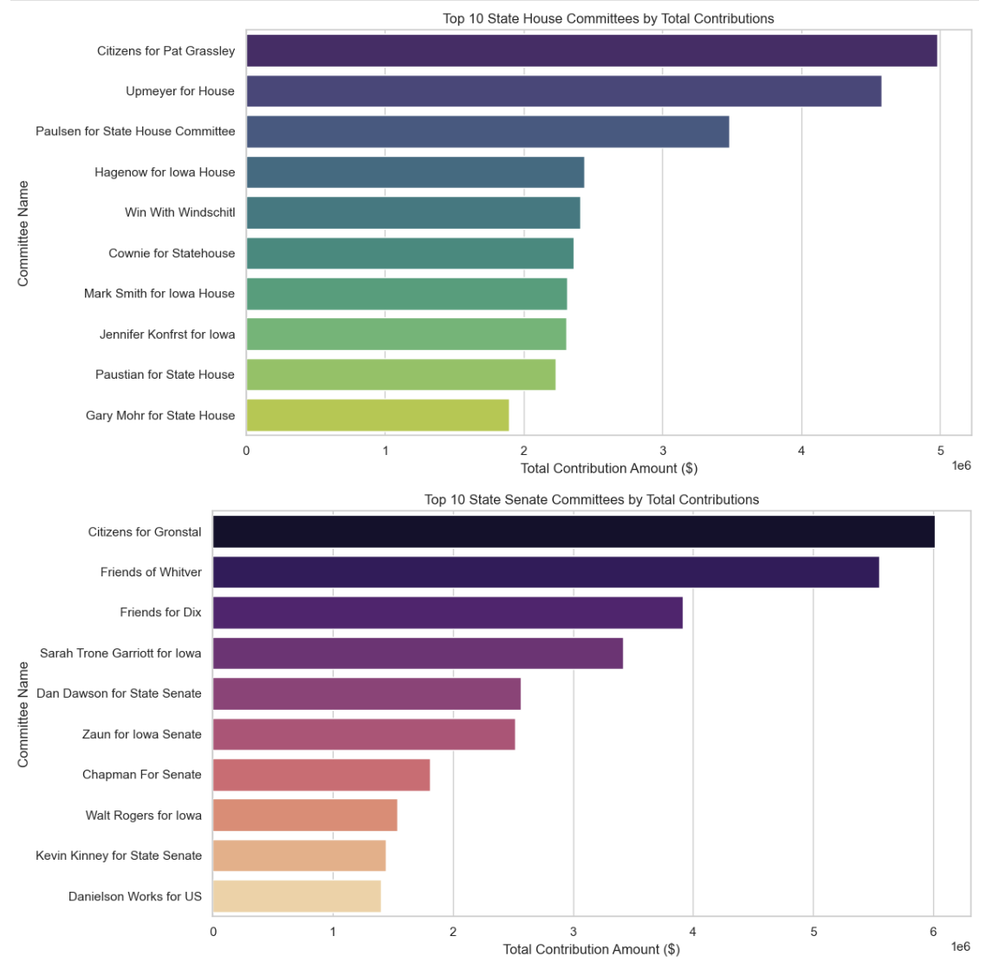

2. Expenditure Analysis
2.1 Total Expenditures Over the Years
• Description: A line plot shows the trend of total expenditures over the years.
• Observations:
• Expenditures exhibit a cyclical pattern, peaking during election years.
• The highest peaks were observed in 2020, indicating significant spending during this cycle.
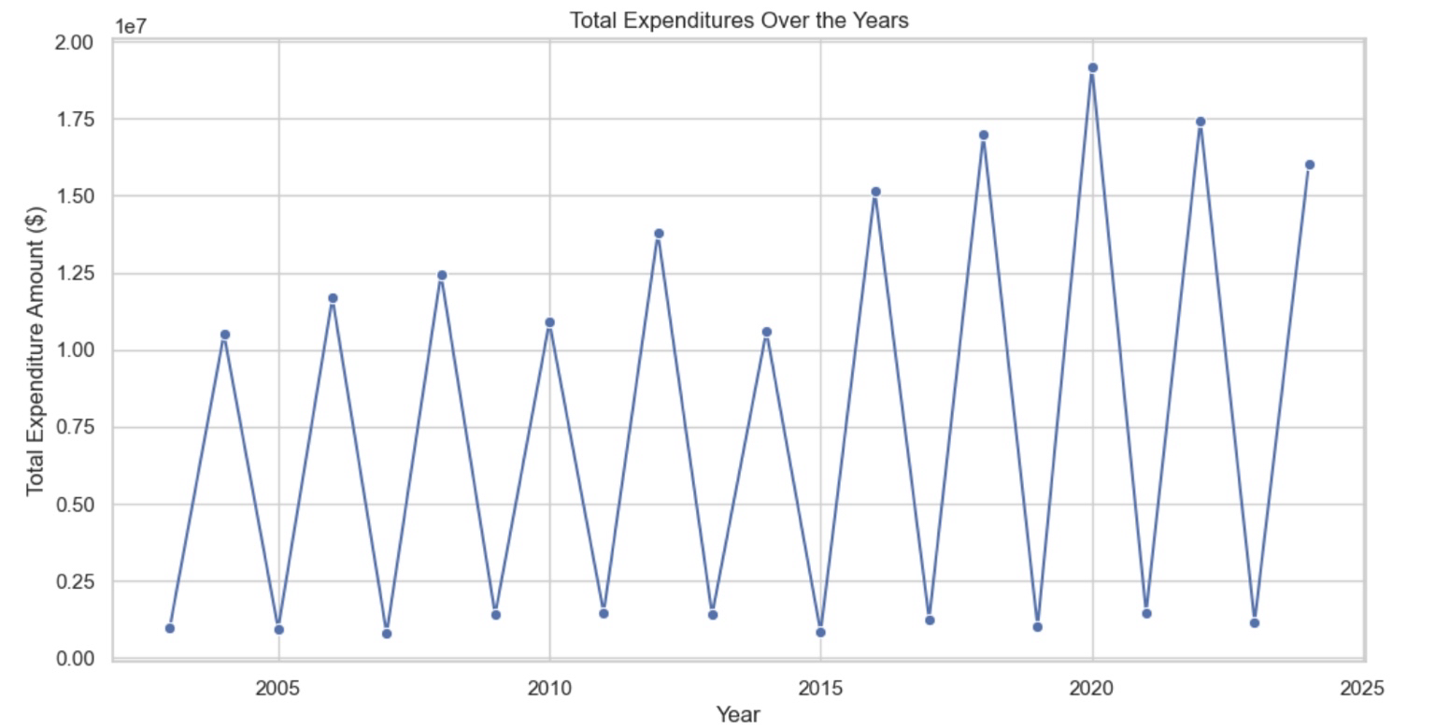
2.2 Expenditures by Committee Type
• Description: Expenditures were analyzed by State House and State Senate committees.
• Observations:
• State House committees spent more overall compared to State Senate committees.
• Both committee types follow similar trends, with peaks aligning with election years.
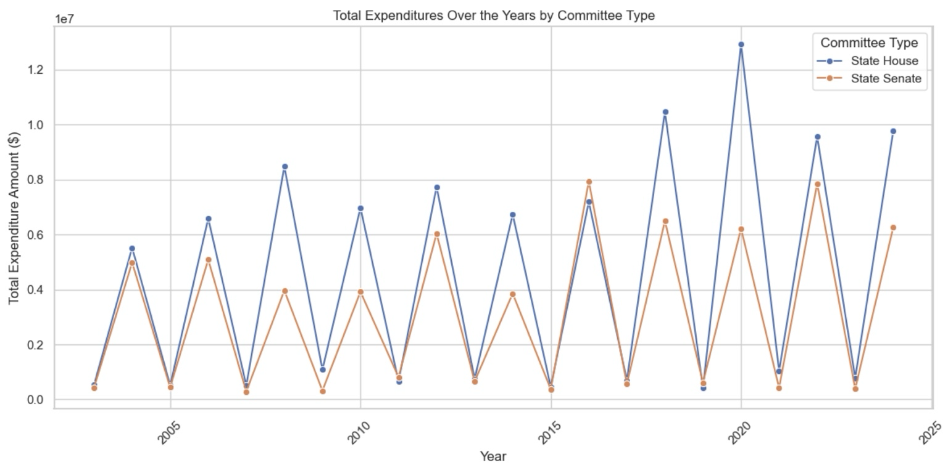

2.3 Top 10 Committees by Expenditures
• Description: A bar chart presents the top committees by total expenditures.
• Observations:
• Top Committees:
• Citizens for Gronstal and Citizens for Pat Grassley incurred the highest expenditures.
• State House committees, such as Upmeyer for House and Paulsen for State House Committee, also feature prominently.
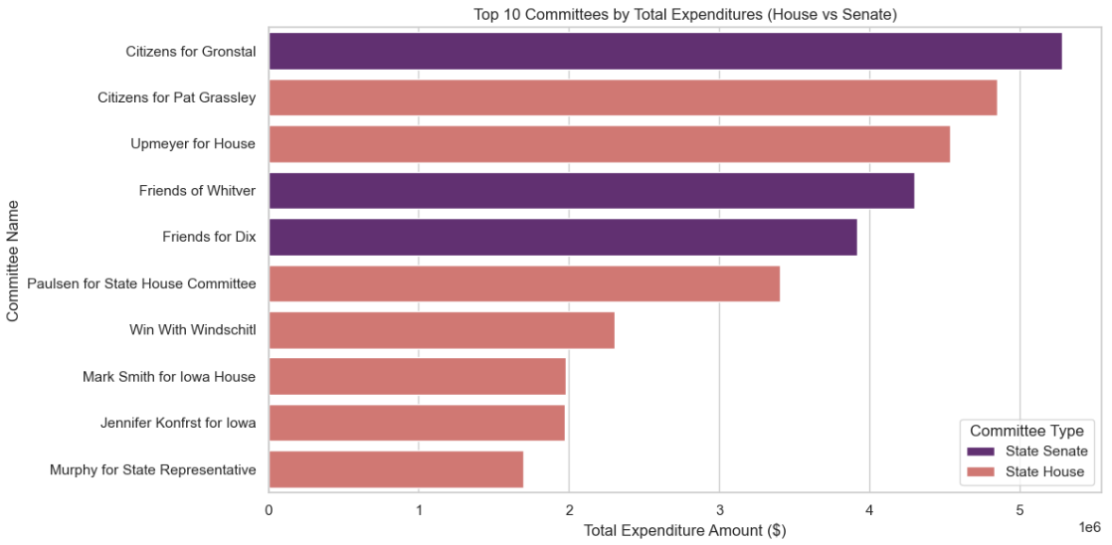
2.4 Top Expenditures for State House and State Senate
• State House Committees:
• Citizens for Pat Grassley and Upmeyer for House had the highest expenditures.
• State Senate Committees:
• Citizens for Gronstal and Friends of Whitver lead expenditures.
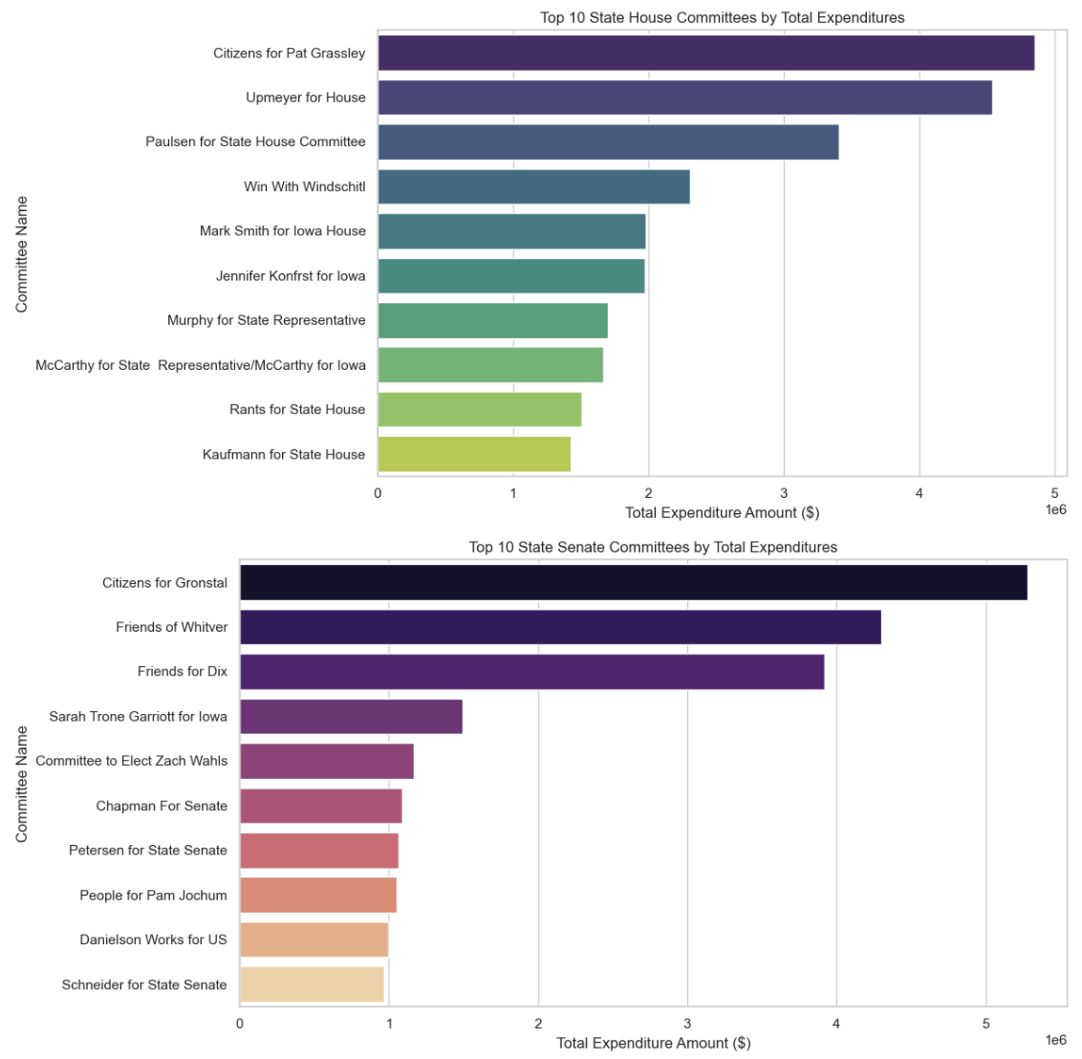
2.5 Top 10 Receiving Organizations
• Description: Analysis of the top receiving organizations for expenditures reveals key recipients.
• Observations:
• State Senate:
• The Republican Party of Iowa and Iowa Democratic Party were the largest recipients.
• Other notable recipients include Victory Enterprises and Carter Printing.
• State House:
• The Republican Party of Iowa received the highest expenditures, followed by the Iowa Democratic Party.
• Media and printing companies, such as Carter Printing and Victory Enterprises, are prominent recipients.
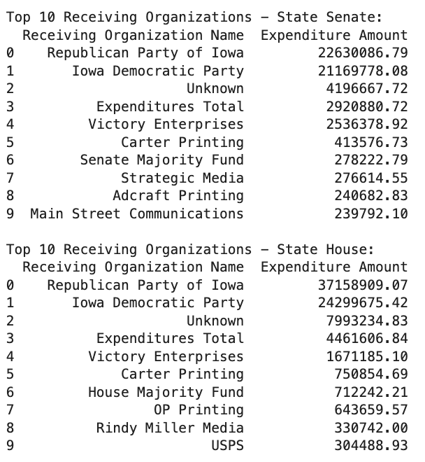

3. Correlation Analysis
Description: Correlations between key metrics such as Contribution Amount, Expenditure Amount, Net Balance, and Contribution-to-Expenditure Ratio were examined.
Key Observations:
• A strong positive correlation (0.74) exists between Contribution Amount and Expenditure Amount, indicating that higher contributions often lead to higher expenditures.
• Net Balance shows a moderate correlation (0.71) with Contribution Amount but negligible correlation with Expenditure Amount.
• The Contribution-to-Expenditure Ratio has a near-zero correlation with other metrics, reflecting minimal influence.

Potential Overfitting in Models:
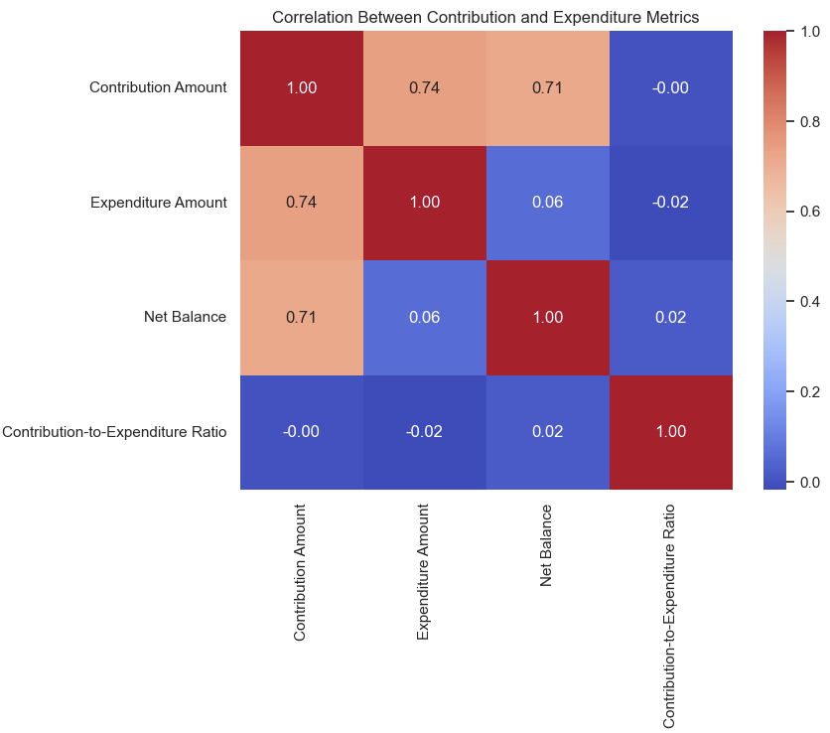

The strong correlation between Contribution Amount and Expenditure Amount suggests a risk of overfitting when these features are used in predictive models. Overfitting may cause models to generalize poorly on unseen data.

Steps to Address Overfitting:

1. Feature Selection: Evaluate the relevance of highly correlated variables and exclude redundant ones.

2. Regularization Techniques: Use techniques like Lasso or Ridge Regression to penalize large coefficients.

3. Cross-Validation: Implement k-fold cross-validation to assess model performance on unseen data.

4. Hyperparameter Tuning: Optimize model parameters (e.g., tree depth in Random Forest) to reduce overfitting.

4. Machine Learning Analysis

Description: A predictive analysis was conducted using multiple regression models to forecast Expenditure Amount based on Contribution Amount and Year.
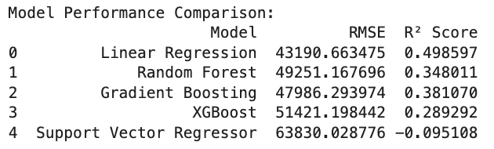
Observations:
• Linear Regression outperformed other models with the highest R² Score (0.50) and the lowest RMSE.
• Random Forest and Gradient Boosting showed moderate performance.
• Support Vector Regressor underperformed, reflecting poor suitability for the data.
Addressing Overfitting in Random Forest:

GridSearchCV was used to tune hyperparameters:
• Best Parameters: {'max_depth': 10, 'min_samples_split': 2, 'n_estimators': 50}
• Performance After Tuning:
• RMSE: 49,909.33
• R² Score: 0.33
Stacking Regressor:
• Combining Linear Regression, Random Forest, and Gradient Boosting in a Stacking Model improved performance:
• RMSE: 45,208.88
• R² Score: 0.45

5. Cross-Validation for Stacking Model

A 5-fold cross-validation further validated the Stacking Regressor’s robustness:

• Mean R² Score: 0.4463

• Standard Deviation: 0.1164

Time Series Analysis
Time Series Analysis (TSA) is a statistical technique used to analyze data points collected or recorded over time. The goal is to identify trends, patterns, and seasonality in the data to make accurate forecasts for future observations. TSA is widely applied in various domains, such as economics, finance, and resource planning

Model Selection and Focus on Expenditure Amount:
The expenditure amount was chosen as the primary variable for analysis because it represents the financial outflow trends over time, which are critical for understanding resource allocation and forecasting future needs. The ARIMA and SARIMAX models were selected due to their ability to model and forecast non-stationary time series data effectively. These models account for trends, seasonality, and noise in the data, making them well-suited for our expenditure forecast.

Stationarity Check
The annual expenditure data from 2003 to 2024 indicates a cyclical pattern with significant fluctuations. The overall trend shows periods of rapid increase followed by sharp declines. The key issues observed are:
- The time series is non-stationary, as confirmed by the Augmented Dickey-Fuller (ADF) test, where the p-value of 0.9985 is greater than 0.05.
- First-order differencing was applied to make the series stationary, with the ADF test after differencing showing a p-value of 0.0, confirming stationarity.

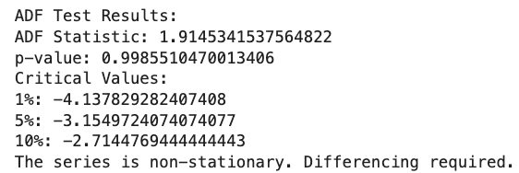

Differencing to Achieve Stationarity
To address the issue of non-stationarity in the time series, first-order differencing was applied to the expenditure data. After differencing, the Augmented Dickey-Fuller (ADF) test was performed again. The results showed an ADF Statistic of -66.5838 and a p-value of 0.0000, which is well below the 0.05 threshold. This confirms that the differenced series is now stationary, allowing us to proceed with model fitting and forecasting.

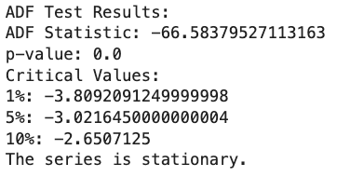

ACF and PACF Plots
The ACF (Autocorrelation Function) and PACF (Partial Autocorrelation Function) plots were analyzed to determine the appropriate parameters for the ARIMA model. The ACF plot shows significant lags at regular intervals, indicating the presence of autocorrelation and the suitability of ARIMA modeling. Additionally, the PACF plot suggests the inclusion of an AR(1) component, which helps in capturing the dependencies within the series.
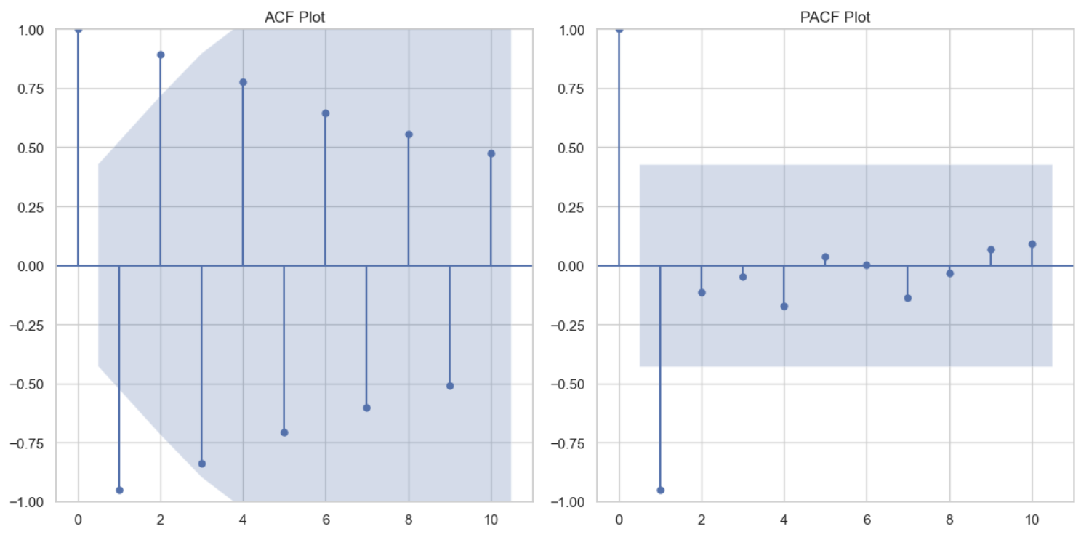

ARIMA Model Fitting
Based on the ACF and PACF analysis, an ARIMA(1,1,1) model was selected and fit to the expenditure data.

Model Summary Highlights:
• AR(1) Coefficient: -1.0000
• MA(1) Coefficient: 0.0246
• Sigma²: 3.297e+12

The residuals of the ARIMA model were plotted to evaluate the model’s performance, as shown in Figure: Residuals of ARIMA Model. The residuals appear to fluctuate around zero, indicating that the model captures much of the variance in the data.
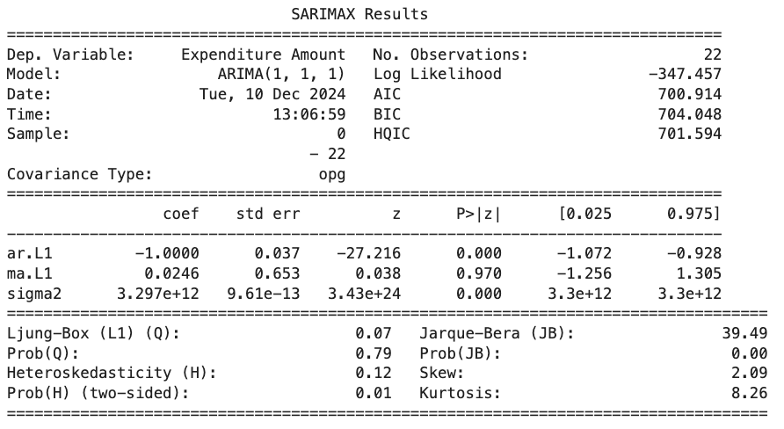

ARIMA Model
The ARIMA model’s forecast is displayed in the graph above. The blue line represents the historical actual expenditure, while the red dashed line indicates the forecasted values for the years 2025–2029.

Key Observations:
The forecasted expenditure values exhibit a sharp alternating pattern between high and low predictions, which deviates significantly from the historical trend. This inconsistency suggests that the model struggles to accurately capture the underlying seasonality and irregular fluctuations in the expenditure data. As a result, the forecast lacks reliability and may be influenced by overfitting or an inappropriate model structure.

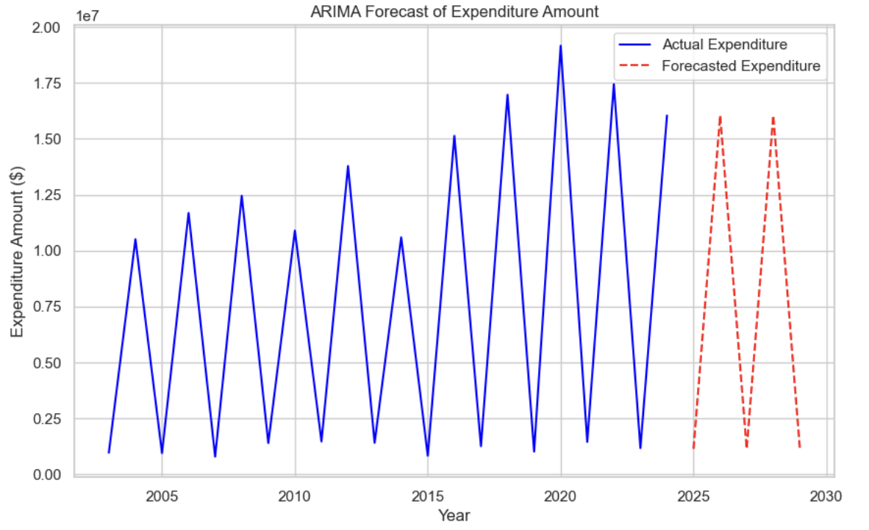

SARIMAX Model Fitting
To enhance forecast accuracy and address the cyclical patterns in the data, a SARIMAX model with parameters (1,1,1)(1,1,1,2) was applied. The SARIMAX model accounts for both trend and seasonal components, improving the model’s ability to capture recurring expenditure patterns.

Ljung-Box Test Results:
• p-value: 0.9483
• Conclusion: The residuals are white noise, indicating that the model provides a good statistical fit without significant autocorrelation remaining in the residuals.

Figure: The SARIMAX forecast plot shows the actual expenditures (blue line) alongside the forecasted values (red dashed line). The SARIMAX model produces smoother and more consistent forecasts compared to the ARIMA model, aligning better with the historical trend and cyclical nature of the data.

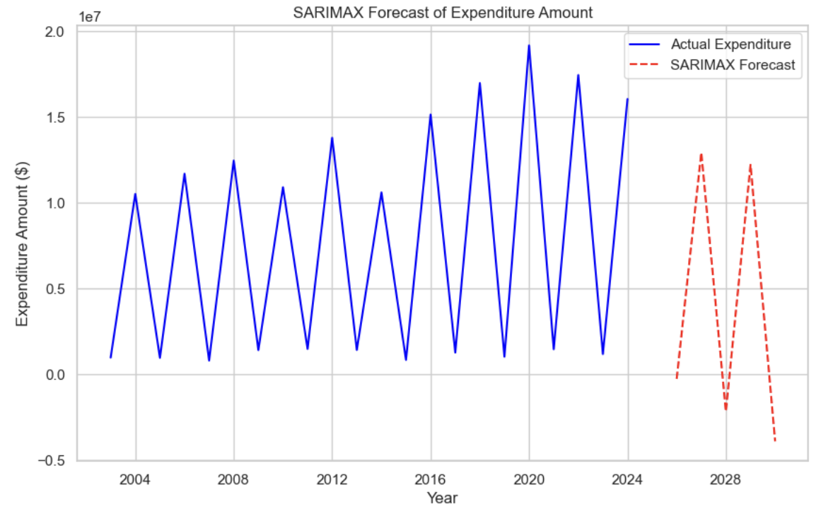

Committee-Wise Expenditure Forecasting
To analyze expenditures at a more granular level, the data was grouped by Committee Type (State House and State Senate), and individual forecasts were generated for each category.

State House Forecast:
• The forecast for State House expenditures shows alternating zero and high values. This irregular pattern suggests model instability or overfitting, likely due to the limited data and extreme fluctuations in historical values.

State Senate Forecast:
• A similar issue is observed for the State Senate forecast, where values alternate between zero and high predictions. This inconsistency highlights challenges in capturing patterns accurately within the data at the committee level.

The irregular forecasts for both committee types indicate that further refinement of the model or exploration of alternative techniques may be required to achieve reliable results.

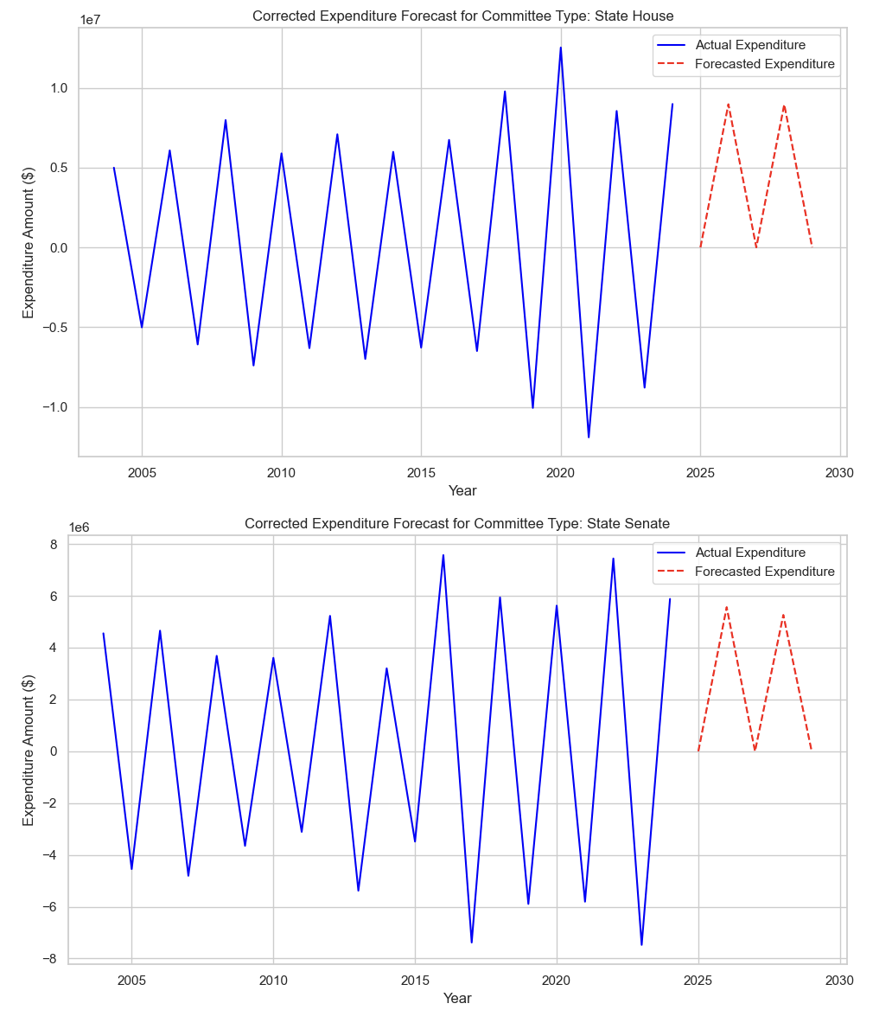

Negative Expenditure Analysis
During the time series analysis, negative expenditure values were identified across multiple years. These anomalies can occur due to data entry errors, refunds, or accounting adjustments within the expenditure records.
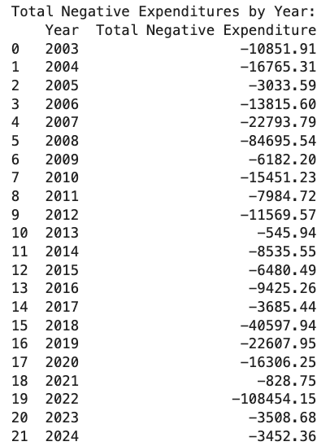

The presence of negative expenditures introduces irregularities in the time series, which can distort the accuracy of forecasting models like ARIMA. These anomalies impact the model’s ability to learn consistent patterns and lead to unreliable predictions. Cleaning or appropriately handling such values is critical for improving forecast performance and model stability.

Key Findings and Recommendations

Key Findings
- Expenditure and Contribution Trends:
• Contributions and expenditures for the State Senate and State House exhibited cyclical trends, with peaks occurring at regular intervals, particularly during election years.
• The ARIMA and SARIMAX models highlighted significant patterns but struggled to align forecasts with historical trends due to irregular data behavior.
- Model Performance Issues:
• ARIMA and SARIMAX models encountered challenges in providing accurate forecasts, particularly due to alternating high and zero values in the predictions. This discrepancy is attributed to data anomalies and limited historical observations.
• Residual analysis and diagnostic tests (e.g., Ljung-Box test) revealed that while the SARIMAX model had a good fit with white noise residuals, forecasting irregularities persisted.
- Negative Expenditure Values:
• Negative expenditures identified in multiple years (e.g., 2003, 2008, and 2022) suggest potential data entry errors, refunds, or accounting corrections. These anomalies required correction for stable model performance.
- Committee-Wise Insights:
• Committee-level forecasts for State House and State Senate campaigns displayed similar irregular patterns, with forecasts alternating between zero and high values, limiting their interpretability.

Recommendations
- Data Quality Improvement:
• Address data anomalies, such as negative expenditure values, by implementing robust validation processes during data collection and entry.
• Ensure that all paper-filed reports are digitized and incorporated into the datasets to improve completeness.
- Enhanced Granularity:
• Improve the granularity of expenditure records by categorizing spending purposes and providing additional details. This will allow for deeper insights into how campaign funds are allocated and their impact.
• Include geographic information for all transactions to enable comprehensive geospatial analyses.
- Expanded Data Scope:
• Extend the datasets to include election outcomes (e.g., winners, vote counts, and victory margins) to evaluate the relationship between campaign expenditures, contributions, and electoral success.
• Incorporate earlier election cycles to analyze long-term trends and enhance the reliability of time series forecasting.

Conclusion
This project analyzed campaign contributions and expenditures for the State Senate and State House of the Iowa General Assembly from 2003 to the present. The analysis revealed cyclical trends in expenditures, with peaks occurring primarily during election years. Committee-wise expenditure forecasting was performed for State House and State Senate, but irregular patterns, such as alternating high and zero values, were observed.
Time series models, specifically ARIMA and SARIMAX, were applied to forecast future expenditures. The ARIMA (1,1,1) model produced inconsistent forecasts, suggesting potential overfitting, while the SARIMAX model improved diagnostic metrics, including residual white noise, but still displayed irregular results. Negative expenditure values were identified and addressed, as these anomalies distorted the forecasting process.
Overall, this project successfully provided insights into expenditure trends and committee-wise spending behaviors. However, challenges such as data anomalies, irregular forecasts, and the lack of detailed contributions integration into time series models highlight the need for improved data quality and completeness for future analyses.

References

General References on Campaign Finance Analysis
- Federal Election Commission (FEC). “Campaign Finance Data.” https://www.fec.gov/data/
- National Institute on Money in Politics. “Follow The Money - Campaign Contributions and Spending.” https://www.followthemoney.org/
- OpenSecrets. “Center for Responsive Politics: Campaign Finance Data.” https://www.opensecrets.org/

References for Time Series Analysis
- Hyndman, R. J., & Athanasopoulos, G. (n.d.). Forecasting: Principles and practice. Retrieved from https://otexts.com/fpp3/
- Statsmodels. (n.d.). Time series analysis in Python. Retrieved from https://www.statsmodels.org/stable/index.html
- Brownlee, J. (2020). A gentle introduction to ARIMA for time series forecasting. Machine Learning Mastery. Retrieved from https://machinelearningmastery.com/arima-for-time-series-forecasting/

Machine Learning and Forecasting
- Scikit-learn. (n.d.). Introduction to supervised machine learning. Retrieved from https://scikit-learn.org/stable/

